Turing Machines

Powerful than Finite automata and Pushdown automata

Single one dimensional array of cells, unbounded in both directions. Each cell can hold one symbol.

Information can be read and changed in any order. Hence they are called a tape.

Necessary inputs will be kept in the tape before execution.

Tape content after the execution is the output.

The languages which can be recognized by TM are called recursive language

A TM can be represented as
M = (Q, Σ, ⎡, δ, q_{0,} , F)
where Q – set of states
Σ - i/p alphabet
⎡ - stack alphabet
δ - Q x ⎡ Q x ⎡ x {L,R}
– blank symbol

F – set of final states

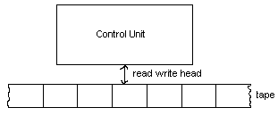

Given below is the description of a TM which move to an infinite loop when given ‘ab’ as input string.
δ(q_{0 ,} a) = (q_{1,} b, R)
δ(q_{0 ,} b) = (q_{1,} b, R)
δ(q_{0 ,} ) = (q_{1,} , R)
δ(q_{0 ,} a) = (q_{1,} a, L)
δ(q_{0 ,} b) = (q_{1,} b, L)
δ(q_{0 ,} ) = (q_{1,} , L)

Exercises

TM accepting 00*
δ(q_{0 ,} 0) = (q_{1,} 0, R)
δ(q_{1 ,} 0) = (q_{1,} 0, R)
δ(q_{0 ,} ) = (q_{2,} , R)

L = {a^{n}b^{n} : n1}

M = {{q₀, q_{1,} q₂, q_{3,} q₄}, {a, b}, {a, b, x, y, }, δ, q_{0,} {q₄}}
δ(q_{0 ,} a) = (q_{1,} x, R)
δ(q_{0 ,} y) = (q_{3,} y, R)

δ(q_{1 ,} a) = (q_{1,} a, R)
δ(q_{1 ,} b) = (q_{2,} b, L)
δ(q_{1 ,} y) = (q_{1,} y, R)

δ(q_{2 ,} a) = (q_{2,} a, L)
δ(q_{2 ,} x) = (q_{0,} x, R)
δ(q_{2 ,} y) = (q_{2,} y, L)

δ(q_{3 ,} y) = (q_{3,} y, R)

δ(q_{3 ,} ) = (q_{4,} , R)

Check whether the given string is palindrome or not.

δ(q_{0 ,} ) = (q_{1,} , R)
δ(q_{1,} a) = (q_{2,} , R)
δ(q_{1,} b) = (q_{5,} , R)
δ(q_{5,} ) = (q_{6,} , L)
δ(q_{5 ,} a) = (q_{5,} a, R)
δ(q_{5 ,} b) = (q_{5,} b, R)
δ(q_{6 ,} b) = (q_{4,} , L)
δ(q_{2 ,} a) = (q_{2,} a, R)
δ(q_{2 ,} b) = (q_{2,} b, R)

δ(q_{2,} ) = (q_{3,} , L)
δ(q_{3,} a) = (q_{4,} , L)
δ(q_{4 ,} a) = (q_{4,} a, L)
δ(q_{4 ,} b) = (q_{4,} b, L)
δ(q_{3 ,} ) = (q_{7,} , R)
δ(q_{0 ,} ) = (q_{7,} , R)
δ(q_{1 ,} ) = (q_{7,} , R)

δ(q_{4,} ) = (q_{1,} , R)

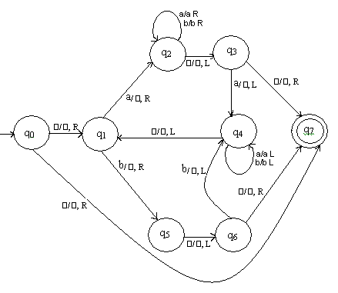

Compute x + y where x,y {0,1}*

δ(q_{0,} 1) = (q_{0,} 1, R)
δ(q_{0,} 0) = (q_{1,} 1, R)
δ(q_{1,} 1) = (q_{1,} 1, R)
δ(q_{1,} ) = (q_{2,} , L)
δ(q_{2 ,} 1) = (q_{3,} 0, L)
δ(q_{3 ,} 1) = (q_{3,} 1, L)
δ(q_{3 ,} ) = (q_{4,} , R)

Compute q₀w q_{f}ww

δ(q_{0,} 1) = (q_{0,} x, R)
δ(q_{0,} ) = (q_{1,} , L)
δ(q_{1,} x) = (q_{2,} 1, R)
δ(q_{2,} 1) = (q_{2,} 1, L)
δ(q_{2 ,} ) = (q_{1,} 1, L)
δ(q_{1 ,} 1) = (q_{1,} 1, L)
δ(q_{1 ,} ) = (q_{3,} , R)

TM that accepts all strings with sub string ‘aba’

δ(q_{0,} a) = (q_{1,} a, R)

δ(q_{0,} b) = (q_{0,} b, R)

δ(q_{1,} a) = (q_{1,} a, R)

δ(q_{1,} b) = (q_{2,} b, R)

δ(q_{2,} a) = (q_{3,} b, R)

δ(q_{2,} b) = (q_{0,} b, R)

δ(q_{3,} a) = (q_{3,} a, R)

δ(q_{3,} b) = (q_{3,} b, R)

δ(q_{3,} ) = (q_{4, ,} L)

Turing Machine with Stay Option

This category of TM’s can remain on the current state after accepting an input character. Hence the transition function can be written as δ - Q x ⎡ Q x ⎡ x {L,R,S}

Let = (,Σ, ⎡, ,, , ) be a standard Turing Machine and M = (Q, Σ, ⎡, δ, q_{0,} , F) be the equivalent machine with stay option. We can simulate the transitions of the TM with stay option as

Case 1

δ(q_{i,} a ) = (q_{j,} b, R) (, a) = (, b, R)

Case 2

δ(q_{i,} a ) = (q_{j,} b, L) (, a) = (, b, L)

Case 3

δ(q_{i,} a ) = (q_{j,} b, N) (, a) = (, c, R)

(, c) = (, b, L)

Exercises

Parenthesis matching

δ(q_{0,} ( ) = (q_{0,} (, R)

δ(q_{0,} *) = (q_{0,} *, R)

δ(q_{0,} ) ) = (q_{1,} *, L)

δ(q_{0,} ) = (q_{2, ,} L)

δ(q_{1,} ( ) = (q_{1,} *, R)

δ(q_{1,} * ) = (q_{1,} *, L)

δ(q_{1,} ) ) = (q_{1,} ), L)

δ(q_{1,} ) = (q_{3,} f, N)

δ(q_{2,} ( ) = (q_{3,} s, N)

δ(q_{2,} * ) = (q_{2,} *, L)

δ(q_{2,} ) ) = (q_{2,} ), L)

δ(q_{2,} ) = (q_{3, 0,} N)

Multiplication of unary numbers

I \ S | α | β | γ | δ | ε
0 | L | R |  | bεL | L
1 | 0βR | aR |  | R | L
a |  |  | 1δR |  | 1δR
b |  |  |  | R | L
; | φN | γL | R | R | L
, | L | R | L |  | αN

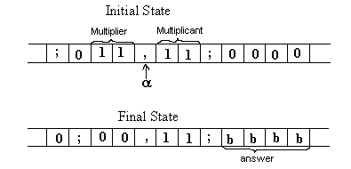

Compute GCD of two unary numbers.

I \ S | α | β | γ | δ
0 | δR | γL | αR | Halt
1 | aβN | bαN | αR | αL
a | L | R | 1L | 0R
b | L | R | 0L | 1R

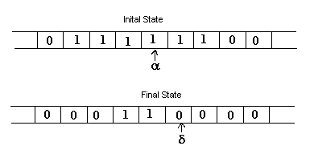

Compute Modulus of unary numbers

δ(q_{0 ,} 0) = (q_{0 ,} 0, R)
δ(q_{0 ,} 1) = (q_{1 ,} a, L)
δ(q_{0 ,} a) = (q_{0 ,} a, R)
δ(q_{0 ,} B) = (q_{4 ,} B, L)

δ(q_{1 ,} 0) = (q_{2 ,} 0, L)
δ(q_{1 ,} a) = (q_{1 ,} a, L)

δ(q_{2,} 0) = (q_{2 ,} 0, L)
δ(q_{2 ,} 1) = (q_{3 ,} a, R)
δ(q_{2,} a) = (q_{2 ,} a, L)
δ(q_{2 ,} B) = (q_{7 ,} B, R)

δ(q_{3 ,} 0) = (q_{0 ,} 0, R)
δ(q_{3 ,} a) = (q_{3 ,} a, R)

δ(q_{4 ,} 0) = (q_{5 ,} 0, L)
δ(q_{4 ,} a) = (q_{4 ,} 1, L)

δ(q_{5 ,} 0) = (q_{5 ,} 0, L)
δ(q_{5 ,} 1) = (q_{6 ,} 1, R)
δ(q_{5 ,} a) = (q_{5 ,} 0, L)

δ(q_{6 ,} 0) = (q_{0 ,} 0, R)

δ(q_{7 ,} 0) = (q_{8 ,} 0, L)
δ(q_{7 ,} a) = (q_{7 ,} 1, R)

δ(q_{8 ,} 1) = (q_{8 ,} 0, L)
δ(q_{8 ,} B) = (q_{9 ,} B, R)

δ(q_{9 ,} 0) = (q_{10 ,} 0, L)
δ(q_{9 ,} 1) = (q_{10 ,} 0, S)
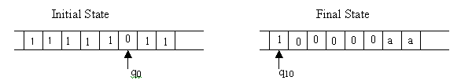 Different types of Turing Machines

Turing Machines with Two Dimensional Tapes
This is a kind of Turing machines that have one finite control, one read-write head and one two dimensional tape. The tape has the top end and the left end but extends indefinitely to the right and down. It is divided into rows of small squares. For any Turing machine of this type there is a Turing machine with a one dimensional tape that is equally powerful, that is, the former can be simulated by the latter.
To simulate a two dimensional tape with a one dimensional tape, first we map the squares of the two dimensional tape to those of the one dimensional tape diagonally as shown in the following tables:
Two Dimensional Tape
Here the numbers indicate the correspondence of squares in the two tapes: square i of the two dimensional tape is mapped to square i of the one dimensional tape. h and v are symbols which are not in the tape alphabet and they are used to mark the left and the top end of the tape, respectively.
One Dimensional Tape
v | v | v | v | v | v | v | . . . | . . .
h | 1 | 2 | 6 | 7 | 15 | 16 | . . . | . . .
h | 3 | 5 | 8 | 14 | 17 | 26 | . . . | . . .
h | 4 | 9 | 13 | 18 | 25 | . . . | . . . | . . .
h | 10 | 12 | 19 | 24 | . . . | . . . | . . . | . . .
h | 11 | 20 | 23 | . . . | . . . | . . . | . . . | . . .
h | 21 | 22 | . . .< .> | . . . | . . . | . . . | . . . | . . .
. . . | . . . | . . . | . . . | . . . | . . . | . . . | . . . | . . .
The head of a two dimensional tape moves one square up, down, left or right.
Let us simulate this head move with a one dimensional tape.
Let i be the head position of the two dimensional tape. If the head moves down from i, then move the head of the one dimensional tape to right until it hits h or v counting the number of squares it has visited after i. Let k be the number of squares visited by the head of the one dimensional tape. If h was hit first, then from h move the head of the one dimensional tape further right to the k-th square from h. That is the square corresponding to the square below i in the two dimensional tape. If v was hit first, then (k+1)-th square to the right from v is the new head position.
For example, suppose that the head position is at 8 for the two dimensional tape in the above table, that is i = 8. If the head moves down to position 13, then for the one dimensional tape, the head moves from position 8 to right. Then it meets h first, which is the third square from 8. Thus from h, move 3 positions to the right. That is the head position of the one dimensional tape corresponding to 13 on the two dimensional tape.
If i = 5 and the head moves down on the other hand, then on the one dimensional tape the head moves to the right and it hits v first, which is the second square from i = 5. Thus this time the third square is the head position of the one dimensional tape corresponding to 9 on the two dimensional tape.
Similarly formulas can be found for the head position on the one dimensional tape corresponding to move up, right or left on the two dimensional tape. Details are omitted. Thus some Turing machines with a one dimensional tape can simulate every move of a Turing machine with one two dimensional tape. Hence they are at least as powerful as Turing machines with a two dimensional tape. Since Turing machines with a two dimensional tape obviously can simulate Turing machines with a one dimensional tape, it can be said that they are equally powerful.
v | 1 | v | 2 | 3 | h | 4 | 5 | 6 | v | 7 | 8 | 9 | 10 | h | 11 | . . . | . . .

Turing Machines with Multiple Tapes :
This is a kind of Turing machines that have one finite control and more than one tapes each with its own read-write head. It is denoted by a 5-tuple < Q , , , q₀, > . Its transition function is a partial function
: Q ( {} )^{n} -> ( Q { h } ) ( {} )^{n} { R , L , S }^{n} .
A configuration for this kind of Turing machine must show the current state the machine is in and the state of each tape.
It can be proven that any language accepted by an n-tape Turing machine can be accepted by a one tape Turing machine and that any function computed by an n-tape Turing machine can be computed by a one tape Turing machine. Since the converses are obviously true, one can say that one tape Turing machines are as powerful as n-tape Turing machines.

Turing Machines with Multiple Heads :
This is a kind of Turing machines that have one finite control and one tape but more than one read-write heads. In each state only one of the heads is allowed to read and write. It is denoted by a 5-tuple < Q , , , q₀, >. The transition function is a partial function
: Q { H₁ , H₂ ... , H_{n} } ( {} ) -> ( Q { h } ) ( {} { R , L , S } ,
where H₁ , H₂ ... , H_{n} denote the tape heads.
It can be easily seen that this type of Turing machines are as powerful as one tape Turing machines.

Turing Machines with Infinite Tape :
This is a kind of Turing machines that have one finite control and one tape which extends infinitely in both directions.
It turns out that this type of Turing machines are only as powerful as one tape Turing machines whose tape has a left end.

Nondeterministic Turing Machines

A nondeterministic Turing machine is a Turing machine which, like nondeterministic finite automata, at any state it is in and for the tape symbol it is reading, can take any action selecting from a set of specified actions rather than taking one definite predetermined action. Even in the same situation it may take different actions at different times. Here an action means the combination of writing a symbol on the tape, moving the tape head and going to a next state. For example let us consider the language L = { ww : w { a , b }* } . Given a string x, a nondeterministic Turing machine that accepts this language L would first guess the midpoint of x, that is the place where the second half of x starts. Then it would compare the first half of x with the second half by comparing the i-th symbol of the first half with the i-th symbol of the second half for i = 1, 2, ... . A deterministic Turing machine, on the other hand, can not guess the midpoint of the string x. It must find the midpoint by for example pairing off symbols from either end of x.
Formally a non deterministic Turing machine is a Turing machine whose transition function takes values that are subsets of ( Q { h } ) ( {} { R , L , S } .
As in the case of NFA, it is understood that a nondeterministic Turing machine at any configuration selects one combination of next state, tape symbol and head movement out of the set of triples without following any specific predetermined rule. It can be shown that a nondeterministic Turing machine is only as powerful as a deterministic Turing machine.

Recursive Language
A language L on Σ is said to be recursive if there is a Turing machine M that accepts L and halts on every w in Σ⁺ and rejects if not in Σ⁺

Recursively Enumerable Language

A language L is recursively enumerable if there exists a turing machine that accepts it. Accepting a language means strings not in L may be rejected or moved to an infinite loop

All recursive languages are recursively enumerable

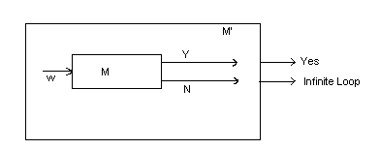

Complement of a recursive language is recursive

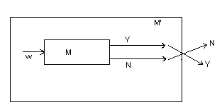

If L and are recursively enumerable then L is recursive

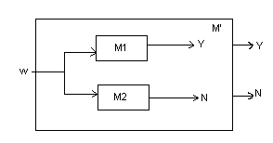

Let M1 be the machine corresponding to L and M2 the machine for . If w is given as input, it will be accepted by either M1 or M2. If accepted by M1, M’ returns Y else N. Hence language accepted by M’ is recursive.

Undecidablility

A problem that cannot be solved for all cases by any algorithm, whose associated language cannot be recognized by a Turing machine that halts for all inputs

Halting Problem
Halting problem is the determination of whether a Turing machine will come to a halt given a particular input program. Given description of Turing machine M, and input w, does M starting at initial point q₀w, perform a computation and eventually halts ?
i.e., q₀w_{M}w x₁q_{y}x₂ ₋ if halts

q₀w_{M}w y₁q_{n}y₂ ₋ if never halts

Halting Problem is Undecidable

Assume that Halting Problem is undecidable. Then

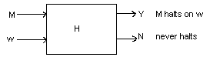

Let L be a recursive enumerable language. And M, the Turing machine that accepts L.

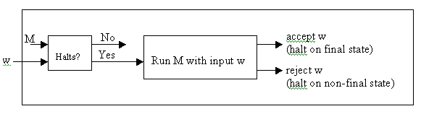

For the above to be true, L should be a recursive language. We know that all recursive enumerable languages are not recursive. Hence such a Turing Machine never exists. This is contradictory with our initial assumption.

State Entry Problem

The problem is to determine whether Turing machine M, when given input w, ever enters state q.

State Entry Problem is undecidable
To prove that State Entry problem is undecidable:
- Assume that you have an effective procedure (Turing machine or any other kind of algorithm) to solve problem State Entry problem.
- Show how to use the program for State Entry problem to solve the Halting Problem.
- Conclude that problem State Entry problem can't be solved.
The only way a Turing machine M halts is if it enters a state q for which some transition function (q_{i}, a_{i}) is undefined. Add a new final state Z to the Turing machine, and add all these missing transitions to lead to state Z.
Now use the (assumed) state-entry procedure to test whether state Z is ever entered when M is given input w. This will reveal whether the original machine M halts. We conclude that it must not be possible to build the assumed state-entry procedure.

